**Ginger up your luncheon**

Where do you take a high-powered worldwide tycoon to lunch in Sydney?

The Malaya at King St Wharf is the latest incarnation of this Sydney institution, which has been around for over 40 years.

Run with style and panache by proprietor Lance Wong, it is one of Sydney’s coolest Asian restaurants and a byword for long lunch among Sydney media types.

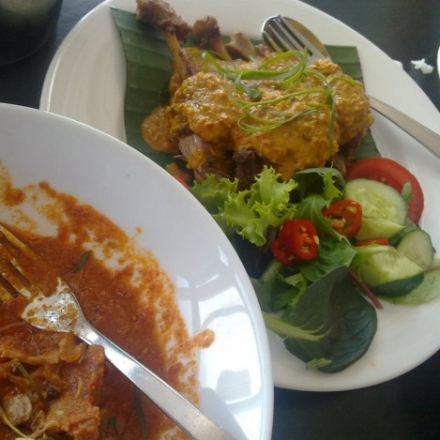

We begin with the seafood rolls, whose crisp freshness take the edge off your hunger.

While we chat the Malaya’s beef curry arrives, a heavenly blend of coconut and heavily gingered, it has been a great influence on my own curries over the years.

The kapitan prawn, parcels of crisp battered succulent fresh prawns in a penang sauce, and a new addition to the menu, which Lance Wong got me to try last time I was at the Malaya, duck marylands falling off the bone in a light curry sauce.

Soon I am sweating and I’m calling for more Tigers to accompany the Malay’s Pinot Gris. Barrie, on his way to a meeting after lunch, sticks to mineral water. I resolve to emulate him next time I’m breaking bread with such a heavy hitter.

The service is unobtrusive and we have been given a table on the deck. The sun sparkles off the water gently lapping against the leviathans tied up at the Maritime Museum across the water at Darling Harbour, juggernauts of bygone ages, as we discuss the future of the internet.

http://www.themalaya.com.au/persistent/templateimages/spacer.gif

|  |  |  |  |
| --- | --- | --- | --- |
| |  |  | | --- | --- | | The Malaya  39 Lime Street  King Street Sydney NSW 2000 Australia  +61 292791170  www.themalaya.com.au |  |  |  | | --- | | PARKING  Secure Parking, 1 Shelley Street, Entrance on Shelley Street.  Mon - Thurs 7am till Midnight, Fri 7am till 2am, Sat 8am till 2am, Sun 8am till 10pm.  *(2 minute walk to The Malaya)* | |